2. DEVELOPMENT OF A CLOUD-EDGE COMMUNICATION MODEL FOR WIRELESS HEALTHCARE MONITORING
1. Introduction
Wireless healthcare monitoring enables continuous observation of patient health parameters using wearable and wireless sensors. Conventional cloud-only healthcare systems transmit all sensor information to a remote cloud, which can introduce communication delay and consume unnecessary bandwidth.
A cloud-edge communication model is therefore proposed in which critical healthcare data is processed at an edge gateway close to the patient, while the cloud is used for long-term storage, advanced analytics, and centralized healthcare management.
The main objective is to provide low-latency monitoring, fast abnormality detection, reduced communication overhead, security, and reliable healthcare services.
2. Objectives
The proposed system aims to:
- Continuously monitor patient health parameters.
- Reduce healthcare communication latency.
- Detect abnormal conditions at the edge.
- Generate fast emergency alerts.
- Reduce unnecessary cloud communication.
- Store patient history in the cloud.
- Support AI-based healthcare analysis.
- Provide secure communication between patients and healthcare providers.

3. Proposed Architecture
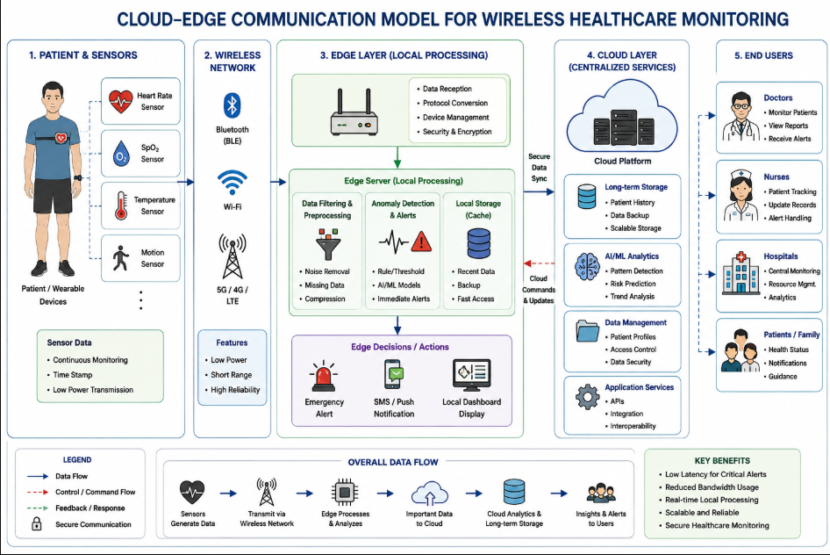
4. System Components
4.1 Wearable Sensors
Wearable sensors continuously measure physiological parameters such as:
- Heart rate
- SpO₂
- Body temperature
- Other required medical parameters
4.2 Wireless Communication
Bluetooth, Wi-Fi, or 5G can be used to transfer sensor information from the patient to the nearby edge gateway.
4.3 Edge Gateway
The edge gateway receives sensor data and provides local connectivity and preprocessing.
4.4 Edge Server
The edge server performs data filtering, feature extraction, anomaly detection, and immediate decision-making.
4.5 Anomaly Detection Module
The anomaly detection module identifies abnormal physiological conditions using threshold-based or AI/ML-based techniques.
For example:
- Heart rate > 100 bpm → possible abnormal condition.
- SpO₂ < 92% → possible oxygen-level warning.
- Temperature > 38°C → possible fever condition.
These values are used only as simulation thresholds and can be replaced by clinically appropriate thresholds in a real system.
4.6 Cloud Platform
The cloud provides:
- Patient-data storage.
- Historical analysis.
- AI/ML model training.
- Backup.
- Centralized healthcare management.
4.7 Doctor/Hospital Interface
Authorized healthcare professionals can access patient information and receive alerts through a secure application.
5. Working Principle
- Wearable sensors continuously measure patient parameters.
- Sensor data is transmitted wirelessly to the edge gateway.
- The edge server receives the data.
- The edge server filters noise and unnecessary measurements.
- The anomaly detection module analyzes the physiological parameters.
- If an abnormal condition is detected, an emergency alert is generated locally.
- Critical information is transmitted immediately to the healthcare system.
- Normal measurements can be summarized before cloud transmission.
- The cloud stores patient history.
- Cloud AI performs long-term analysis and healthcare prediction.
- Doctors access the processed information through an authorized interface.
6. Cloud-Edge Latency Model
The total communication latency can be represented as:
T_total = T_wireless + T_processing + T_transmission
For edge processing:
T_edge = T_wireless + T_edge-processing
For cloud processing:
T_cloud = T_wireless + T_cloud-uplink + T_cloud-processing
Since the edge server is located close to the patient:
T_edge-processing << T_cloud-uplink + T_cloud-processing
Therefore:
T_edge < T_cloud
This enables faster emergency detection.
7. Edge-Based Healthcare Algorithm
START
↓
Read patient sensor values
↓
Transmit data to edge gateway
↓
Filter/preprocess data
↓
Check heart rate, SpO2 and temperature
↓
Is abnormal condition detected?
/ \
YES NO
↓ ↓
Generate alert Store/process
↓ ↓
Send emergency Periodic cloud
information transmission
\ /
\ /
CLOUD
↓
Long-term storage
↓
Doctor monitoring
↓
END
8. MATLAB Simulation
A MATLAB simulation is developed to model wireless healthcare monitoring and compare edge and cloud processing.
Simulation Parameters
Parameter | Value
Number of sensor samples | 2000
Sampling frequency | 1 sample/sec
Normal heart rate | Approximately 72 bpm
Normal temperature | Approximately 36.8°C
Normal SpO₂ | Approximately 97%
Edge processing delay | 5–7 ms
Wireless delay | 8–11 ms
Cloud uplink delay | 25–40 ms
Cloud processing delay | 30–45 ms

The simulation generates physiological signals and introduces an abnormal event. The edge server detects the abnormal condition and generates an alert.
9. MATLAB Simulation Methodology
The MATLAB model performs the following operations:
- Generate heart-rate samples.
- Generate SpO₂ samples.
- Generate temperature samples.
- Introduce an abnormal patient event.
- Apply threshold-based edge detection.
- Calculate edge-processing latency.
- Calculate cloud-processing latency.
- Compare average latency.
- Calculate the amount of data transmitted.
- Generate MATLAB plots.
Edge Detection Conditions
Heart Rate > 100 bpm → Alarm
SpO2 < 92% → Alarm
Temperature > 38°C → Alarm
The simulation also assumes that the edge node sends only abnormal events and periodic summaries to the cloud instead of transmitting every raw sample.
10. MATLAB Results
The MATLAB program generates the following graphs:
Graph 1 – Heart Rate Monitoring
The graph shows heart-rate variation with time. During the simulated abnormal period, heart rate increases above the defined threshold.
Graph 2 – SpO₂ Monitoring
The graph shows the SpO₂ signal and the alarm threshold. The abnormal event causes SpO₂ to fall below the threshold.
Graph 3 – Cloud vs Edge Latency
The graph compares average processing latency.
The expected observation is:
Edge latency < Cloud latency
because edge processing avoids a large part of the cloud-uplink and remote-processing delay.
Graph 4 – Data Reduction
The graph compares:
Raw sensor data vs Edge-filtered data
The edge system reduces the amount of information transmitted to the cloud.
11. Performance Comparison
Parameter | Cloud-Based Monitoring | Proposed Cloud-Edge Model
Processing location | Remote cloud | Edge + cloud
Emergency response | Higher latency | Lower latency
Raw data transmission | High | Reduced
Real-time detection | Moderate | High
Storage | Excellent | Cloud-based
Local processing | Low | High
Scalability | High | High
Long-term analytics | Excellent | Excellent

12. Security Requirements
Healthcare data is sensitive, so the system should implement:
- User authentication.
- Encryption during wireless communication.
- Secure cloud communication.
- Role-based access control.
- Secure patient identification.
- Data backup.
- Access logging.
Only authorized healthcare personnel should access patient information.
13. Advantages
- Continuous patient monitoring.
- Faster emergency alerts.
- Reduced latency.
- Reduced cloud bandwidth requirement.
- Local abnormality detection.
- Long-term cloud storage.
- Supports AI-based healthcare analysis.
- Scalable to multiple patients.
14. Limitations
- Wearable sensors require reliable battery power.
- Wireless connectivity can fail.
- Edge servers require maintenance.
- Healthcare data requires strong security.
- AI-based decisions require proper validation.
- Edge resources may be limited.
15. Improvements
The proposed system can be improved using:
- 5G/6G communication.
- AI-based anomaly detection.
- Federated learning.
- Edge AI accelerators.
- Secure encryption.
- Redundant edge gateways.
- Intelligent energy management.
- Predictive healthcare analytics.
16. Conclusion
The proposed cloud-edge healthcare architecture combines the low-latency processing capability of edge computing with the storage and analytical capability of cloud computing. Critical patient information can be analyzed near the patient, allowing faster emergency alerts, while summarized and historical information can be stored in the cloud.
Therefore, the cloud-edge model provides an efficient, low-latency, scalable, and intelligent solution for wireless healthcare monitoring.

